BAHRIA UNIVERSITY (KARACHI CAMPUS)
Computer Programming (CSC - 113)
Assignment 02
Fall 2022

Class: BSE 1B Shift: Morning
Course Instructor: MUHAMMAD FAISAL Submission: 4 Dec 2022
Date: 24 Nov 2022 Marks: 05 Points
Student Name: ABDULLAH Registration #: 02131222099



[CLO-3]

Question No 1: Write a program that will use switch statements and calculate the salary of an employee by using the information like Allowances, Provident Fund etc.
Input:
using System;

namespace Abdullah_CP_Assignment_2
{
class Program
{
static void Main(string[] args)
{
string name;
int grade, bS;
double totalSalary;

Console.WriteLine("Please Enter Your Name:");
name = Console.ReadLine();
Console.WriteLine("Please Enter Your Basic salary:");
bS = Convert.ToInt32(Console.ReadLine());
Console.WriteLine("Please Enter Your Grade:");
grade = Convert.ToInt32(Console.ReadLine());
Console.Clear();

switch (grade)
{
case 17:
totalSalary = (bS + (0.05 * bS) + (0.025 * bS) + (0.01 * bS)) - (0.075 * bS);
Console.WriteLine("Mr. {0} your salary is Rs. {1}", name, totalSalary);
break;
case 18:
totalSalary = (bS + (0.055 * bS) + (0.03 * bS) + (0.015 * bS)) - (0.075 * bS);
Console.WriteLine("Mr. {0} your salary is Rs. {1}", name, totalSalary);
break;
case 19:
totalSalary = (bS + (0.06 * bS) + (0.033 * bS) + (0.015 * bS)) - (0.075 * bS);
Console.WriteLine("Mr. {0} your salary is Rs. {1}", name, totalSalary);
break;
default:
Console.WriteLine("Invalid Rank!");
break;
}
}
}
}
Output:
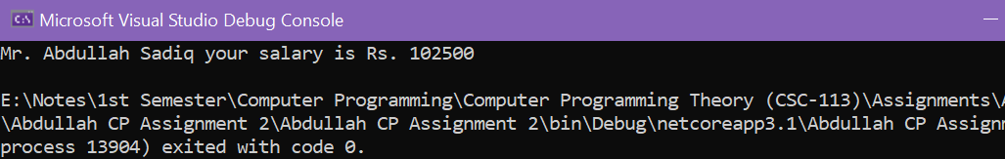
Question No 2: Multiply Array1 with Array2 and stores its result in Array3. Apply matrix rules for multiplication [Row N * Col N]. [Using loop]
Solution:
Input:
using System;

namespace Abdullah_CP_Assignment_2
{
class Program
{
static void Main(string[] args)
{
int[,] prod = new int[4, 3];
int[,] a =
{
{3,4,5},
{6,7,9},
{5,6,8},
{6,4,4}
};
int[,] b =
{
{6,4,2},
{5,2,3},
{7,6,4},
{4,7,8}
};
Console.Write("\na:");
for (int i = 0; i <= 3; i++)
{
Console.WriteLine("");
for (int c = 0; c <= 2; c++)
{
Console.Write("\t{0}", a[i, c]);
}
}
Console.WriteLine("");
Console.Write("\nb:");
for (int i = 0; i <= 3; i++)
{
Console.WriteLine("");
for (int c = 0; c <= 2; c++)
{
Console.Write("\t{0}", b[i, c]);
}
}
Console.WriteLine("");
Console.Write("\na x b:");
for (int i = 0; i <= 3; i++)
{
Console.WriteLine("");
for (int c = 0; c <= 2; c++)
{
prod[i, c] = a[i, c] * b[i, c];
Console.Write("\t{0}", prod[i, c]);
}
}
}
}
}
Output:
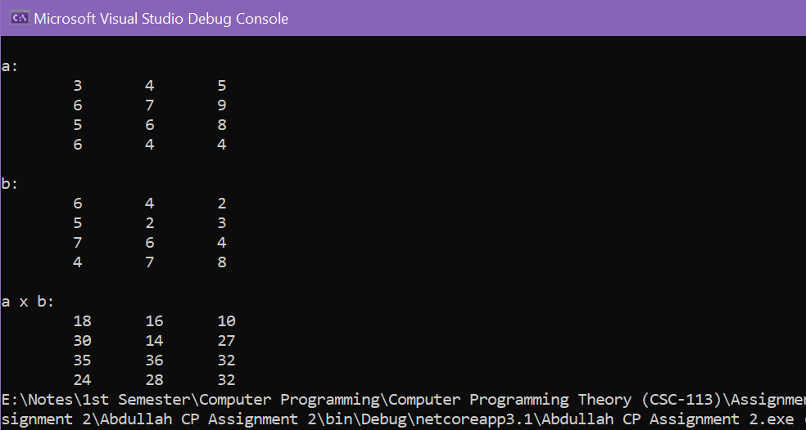
Question No 3: Write a program that will generate the monthly installment and total amount to be paid of personal loan where the insurance is 2% and mark up is 18% per year, initial processing fee is 3%.
Solution:
Input:
using System;

namespace Abdullah_CP_Assignment_2
{
class Program
{
static void Main(string[] args)
{
double loan, year;

Console.WriteLine("Please enter the Amount you want for Loan:");
loan = Convert.ToDouble(Console.ReadLine());
Console.WriteLine("For how many years you want the Amount:");
year = Convert.ToDouble(Console.ReadLine());
Console.Clear();

double ipFee = loan * 0.03;
double insurance = loan * 0.02;
double markUp = (loan * 0.18) * year;
double payableAmount = loan + insurance + markUp;
double months = year * 12;
double monthlyInstallment = payableAmount / months;

Console.WriteLine("\nAmount Taken: {0} \nMonthly Installment: {1}\nInitial Processing Fee: {2} (To be paid once at the time of Approval of Loan).\nInsurance Fee: {3} (2% of Loan)\nTotal ammount to pay after {4} year: {5} Rs.", loan, monthlyInstallment, ipFee, insurance, year, payableAmount);
}
}
}
Output:
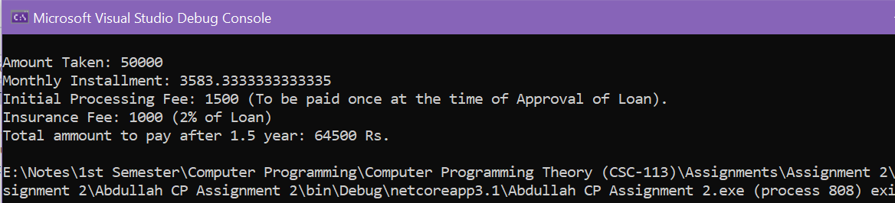
Question No 4: Write an Algorithm to generate total bill of an automobile shop, where the bill is divided into mechanical charges, vehicle parts charges, Auto wash charges and other charges for a customer if the total bill of mechanical charges and vehicle parts charges is over Rs. 10,000/- then the customer will get complementary car wash and car wash charges will be removed from the bill.
Solution:
Step 1: Start
Step 2: Take input from users about services (Vehicle part change, Mechanical work, Auto Wash etc.)
Step 3: Calculate the total charges regarding the services provided to users.
Step 4: Check that if the bill is Larger than 10,000 Rs. If yes, give that customer a
Complementary car wash and remove the car wash charges.
Step 5: Print the Total Billing Amount.
Step 6: Stop
Question No 5: Write a program that will generate the output (Given in Question).
Solution:
Input:
using System;

namespace Abdullah_CP_Assignment_2
{
class Program
{
static void Main(string[] args)
{
for (int i = 1; i <= 3; i++)
{
Console.WriteLine("\nChapter {0}\n",i);
for (int j =1;j<=5;j++)
{
Console.WriteLine("\tSection {0}.{1}",i,j);
}
}
}
}
}
Output:

